**S/W INSTALLATION**

1. Open the ITSM page.
2. Click on Applications tab and then select Service Request Management and then click on Request Entry as below.

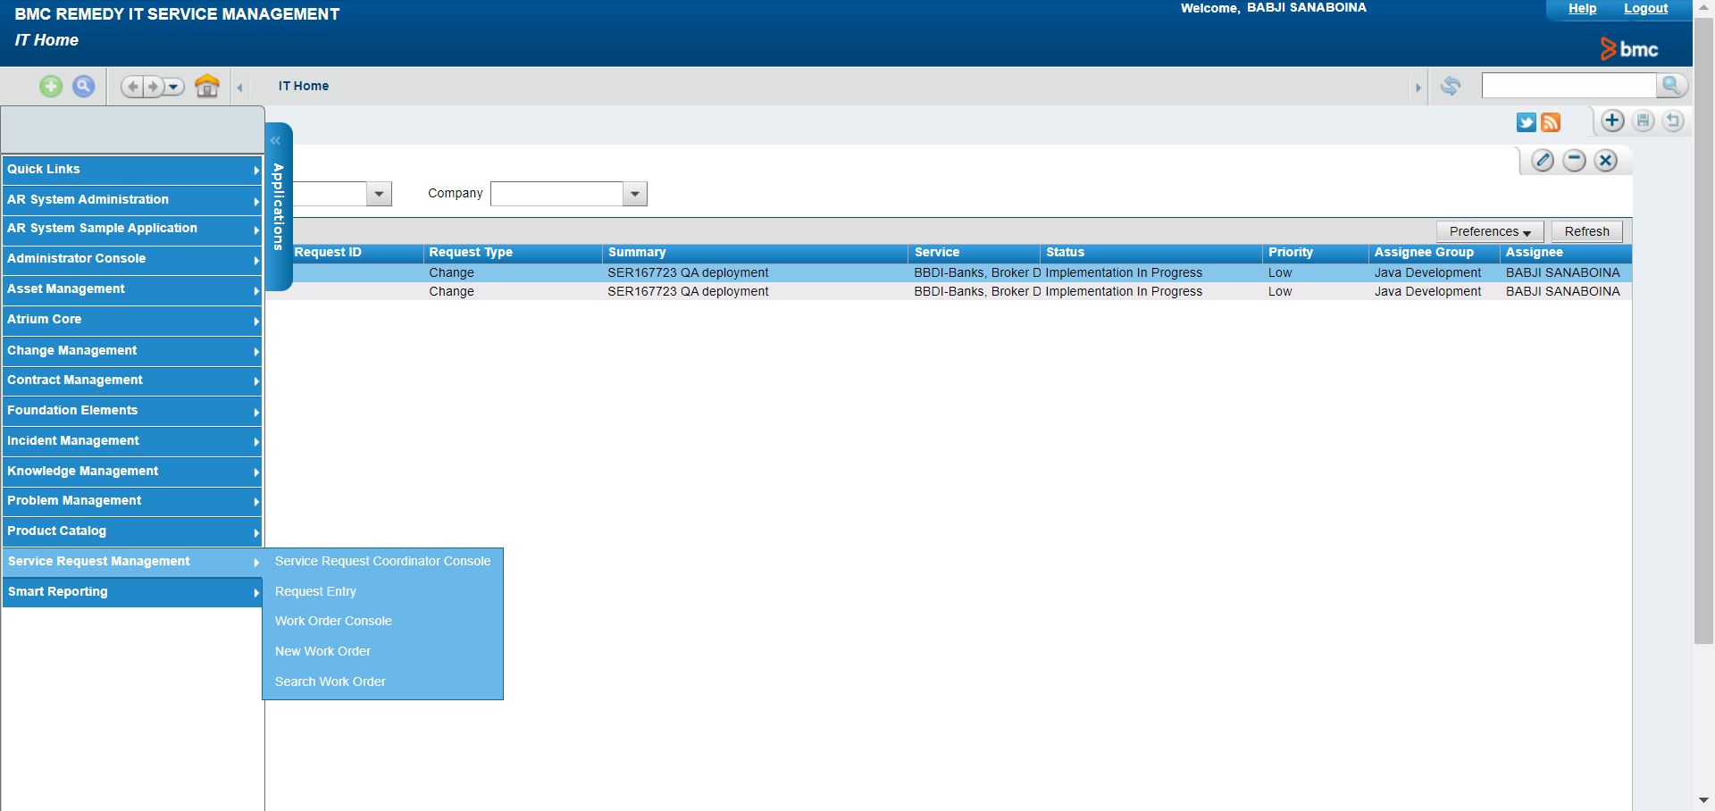

1. In the next screen search with “India Help Desk” and click on enter. Click on India Help Desk under Requests.

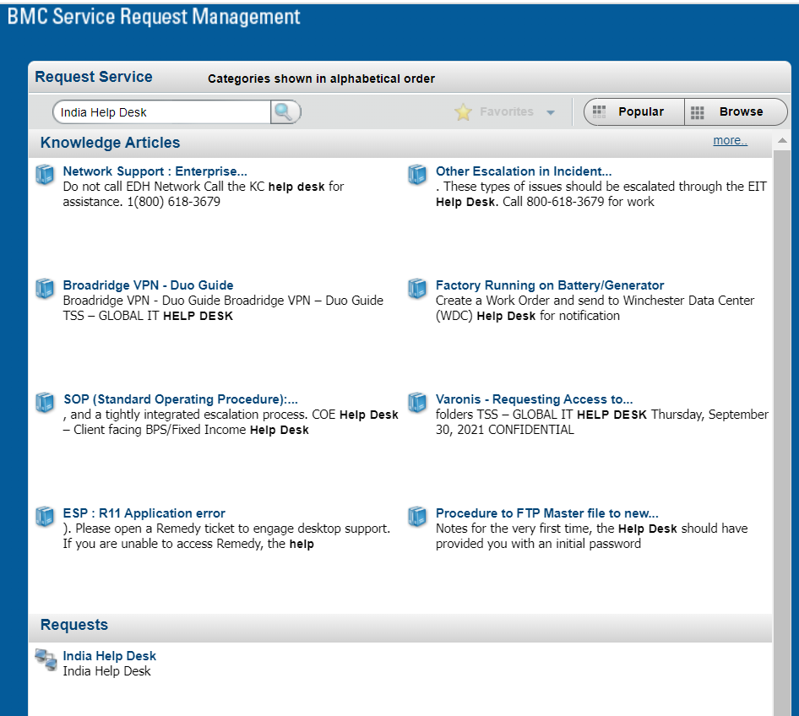

1. Fill all fields as below.

* If the request is raising for ourselves select Self and to raise for others select On Behalf Of.
* We must attach the Manager’s approval (G4 and above) under Attachments tab. Find the attachment mail from the # REQ000000568560.
* We must provide hostname/ip address of the machine and software’s list as listed in the mail.
* Click on submit.

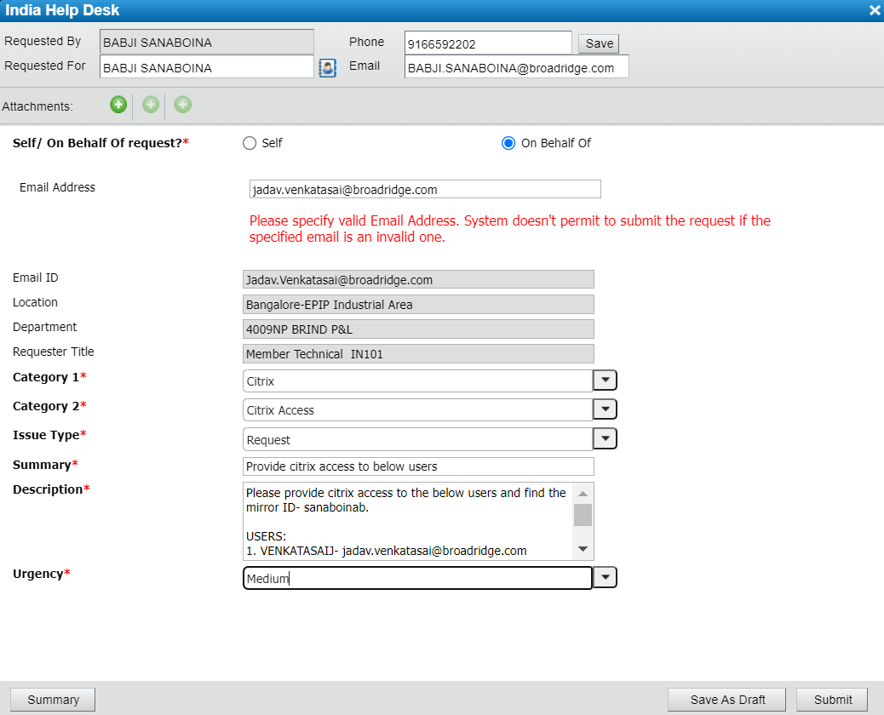

1. Once you submitted it will appear in My request. From next onwards we can go with Request Again to raise adhoc request and make the changes as per need.

